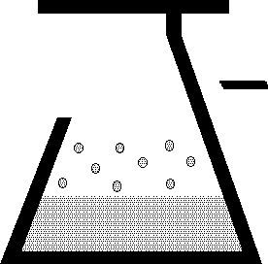 | KEM Scientific, Inc.  Instruments for Science from Scientists | J-KEM® Scientific, Inc.  6970 Olive Blvd.  St. Louis, MO 63130  (314) 863-5536  Fax (314) 863-6070  E-Mail: jkem911@jkem.com

KEM-Net

Temperature and Vacuum
Controller Software Ver 4.0

Notice:
This software is offered free of charge with no guarantee or representation of functionality. The user, as a trained professional should not reply on KEM-Net as a means of controlling a safety critical reaction or any process that can be harmed by improper temperature control.
Document Index

The Main Screen . . . . . . . . . . . . . . . . . . . . . . . . . . . . . . . . . . . . . . . . . . . . . . . . . . . . . . . . . . . . . . 3

Adding and Removing Controllers . . . . . . . . . . . . . . . . . . . . . . . . . . . . . . . . . . . . . . . . . . . . . . . 4

Entering a Setpoint . . . . . . . . . . . . . . . . . . . . . . . . . . . . . . . . . . . . . . . . . . . . . . . . . . . . . . . . . . . 5

Logging Data . . . . . . . . . . . . . . . . . . . . . . . . . . . . . . . . . . . . . . . . . . . . . . . . . . . . . . . . . . . . . . . . 6
ProMode Enabled Controllers . . . . . . . . . . . . . . . . . . . . . . . . . . . . . . . . . . . . . . . . . . . . . . . 8

Ramping . . . . . . . . . . . . . . . . . . . . . . . . . . . . . . . . . . . . . . . . . . . . . . . . . . . . . . . . . . . . . . . . . . . . 11

Graphing . . . . . . . . . . . . . . . . . . . . . . . . . . . . . . . . . . . . . . . . . . . . . . . . . . . . . . . . . . . . . . . . . . . . 15
ProMode Enabled Controllers . . . . . . . . . . . . . . . . . . . . . . . . . . . . . . . . . . . . . . . . . . . . . . . 16

Controlling User Input and Outputs . . . . . . . . . . . . . . . . . . . . . . . . . . . . . . . . . . . . . . . . . . . . . . 17

Editing Meter Parameters . . . . . . . . . . . . . . . . . . . . . . . . . . . . . . . . . . . . . . . . . . . . . . . . . . . . . 20
High and Low Alarms . . . . . . . . . . . . . . . . . . . . . . . . . . . . . . . . . . . . . . . . . . . . . . . . . . . . . . 21
Parameter Levels 1-4 . . . . . . . . . . . . . . . . . . . . . . . . . . . . . . . . . . . . . . . . . . . . . . . . . . . . . . . 24

Application Notes . . . . . . . . . . . . . . . . . . . . . . . . . . . . . . . . . . . . . . . . . . . . . . . . . . . . . . . . . . . . . 26
Note 1 – Example of Entering a Multi-Step Temperature Ramp . . . . . . . . . . . . . . . . . . . . . . 26
Note 2 – Why Doesn’t the Temperature of My Process Match the Ramp Entered? . . . . . . . 28

ASCII Parameters and Protocol for User Written Code . . . . . . . . . . . . . . . . . . . . . . . . . . . . . 29

Loading KEM-Net Drivers . . . . . . . . . . . . . . . . . . . . . . . . . . . . . . . . . . . . . . . . . . . . . . . . . . . . . . 30

NOTICE Windows 8 and 10 no longer automatically load KEM-Net’s drivers, and so it’s necessary to load the drivers manually. Until the controller’s drivers are properly loaded, KEM-Net will not connect to the temperature controller. You’ll know if the drivers are loaded the appearance of KEM-Net’s startup screen. When KEM-Net is started, and the controller is connected to the PC using a USB cable, if an image of the controller appears on the screen (as pictured below), then the drivers are loaded, if the controller does not appear, but rather a message ‘Searching for Connected Devices’, then the drivers are not loaded. For detailed instructions, see the section titled Loading KEM-Net Drivers at the end of the manual.

KEM-Net Standard & KEM-Net ProMode
Kem-Net is offered both as a standard features version (free) and also as an upgraded ‘ProMode’ version. The features implemented in each version are shown in this table

Feature | KEM-Net Standard | KEM-Net ProMode
Connects up to 8 temperature and vacuum controllers. | Yes | Yes
Real-time display of controller digital meter. | Yes | Yes
Real-time graphing of temperature and pressure | Yes | Yes
Real-time graphing of power applied to the heater. | No | Yes
On-screen input of setpoint. | Yes | Yes
Logging of time, temperature, and pressure. | Yes | Yes
Logging of percent power applied to heater. | No | Yes
Logs to GMP compliant (21 CRR, Part 11) data file. | No | Yes
Create, store and run up to 16-step temperature and pressure programs. | Yes | Yes
Program control of KEM-IO inputs and outputs | Yes | Yes
Set High and Low temperature alarms | Yes | Yes
The major advantages of KEM-Net ProMode is:
1) Logs data to a GMP compliant (21 CRR, Part 11) data file.
2) Logs and graphs the power applied to a heater that’s connected to a temperature controller. Being able to view real-time power data allows the researcher to see endo and exothermic reactions as they occur and to get a qualitative understanding of the degree and kinetics of the endo or exotherm.
Any controller can be upgraded to ProMode by entering an Upgrade key (supplied by J-KEM) at a cost of $75.00. Contact J-KEM for more information.

The Main Screen

When KEM-Net software starts, a screen appears indicating that the USB bus is being searched for attached J-KEM temperature and vacuum controllers. Any controller that is found is displayed on the screen. A controller can have 1, 2, 4, or 6 individual meters.
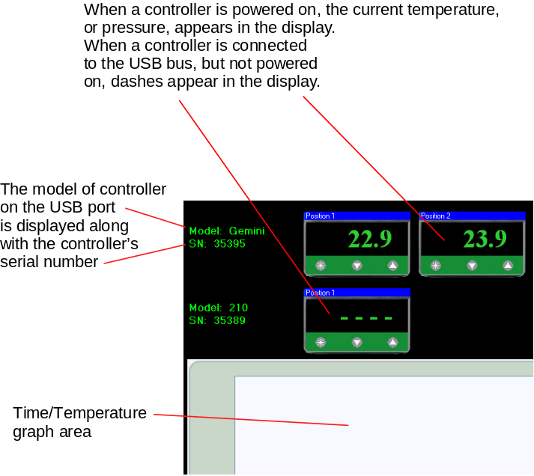

Adding and Removing Controllers

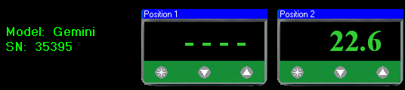 | The application continuously searches the USB bus for connected J-KEM controllers. When a controller is found, it appears on screen. If the meter is powered, the current process value appears on the screen, if not, the screen displays “- - - -“.
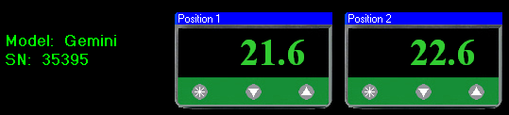 | When power is applied to a meter, its process value appears on the screen.
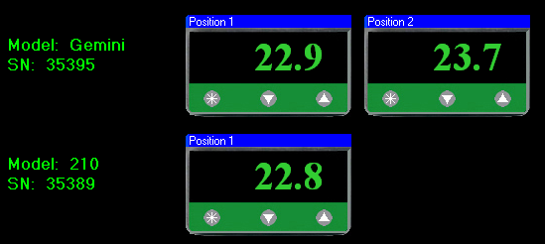 | If a new controller is connected to the PC (i.e., plugged into the PC’s USB port), it automatically appears on the screen. Discovering the new controller can take up to 10 seconds.
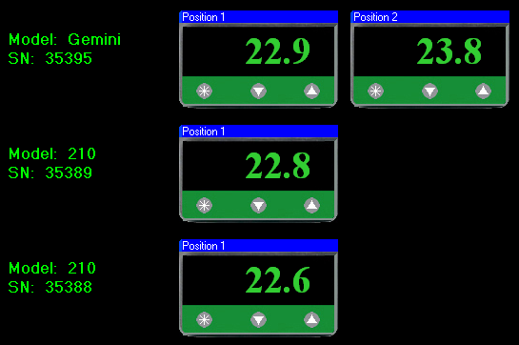 | As controllers are plugged into the PC, they continue to appear on screen.
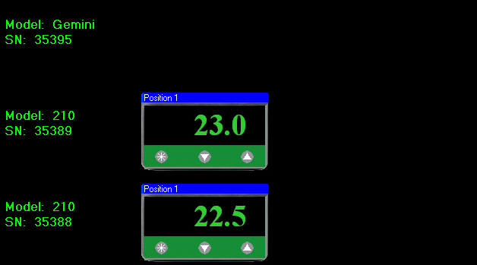 | When a controller is unplugged from the USB port on the PC, the controller disappears, but it place on the screen remains. If the controller is later reconnected, it populates the position reserved for it on the screen.
Entering a Setpoint

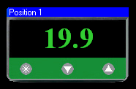  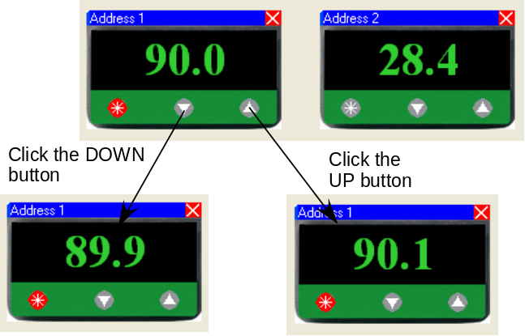  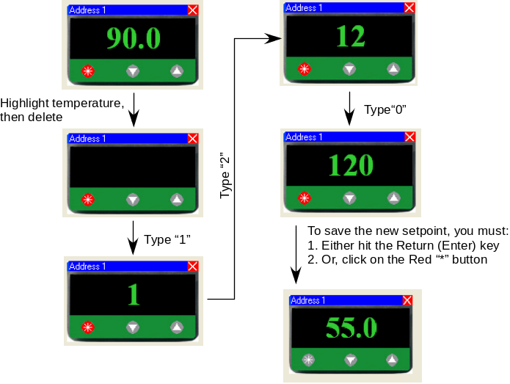  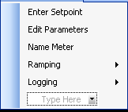 | The normal state of the meter is to show the current temperature or pressure of the attached sensor.  There are 4 ways to enter a new setpoint into the meter.  1) A new setpoint can be entered into the physical meter itself, as would be done normally, without the use of software even when the controller is connected to the PC. A setpoint is physically entered by pressing the physical “*” button on the face of the digital meter, then pressing the Up or Down arrow keys on the meter.  2) A new setpoint can be entered using the software by clicking on the “*” button on the face of the meter as it appears on the PC screen. When in setpoint edit mode, the “*” button turns red and the current meter setpoint appears in the display. While in setpoint edit mode, clicking on the Down button will decrease and clicking on the Up button will increase the setpoint. When the desired setpoint is showing in the display, clicking the red “*” button will upload the newly entered setpoint to the digital meter, which will then return to displaying the current process temperature.  3) Another method for entering a new setpoint is to click the “*” button, placing the meter in setpoint edit mode (the “*” turns red), then highlighting the current setpoint, displayed on the meters face, and typing in the new setpoint. When the desired setpoint is entered (i.e., typed) into the display, clicking the red “*” button will upload the new setpoint to the digital meter.  4) The last method for entering a setpoint is to right click on the face of the meter of interest, then select the Enter Setpoint option from the popup context menu. This placed the meter into setpoint edit mode (the “*” button turns red). Once in edit mode, you can either click on the Up or Down buttons on the meter face to change the setpoint (method 2), or type a new setpoint into the display (method 3). When the new setpoint is displayed, clicking the red “*” button uploads the setpoint to the digital meter and causes the meter to display the sensed process value.
Logging Data

KEM-Net can log process data, time, temperature or pressure, and setpoint, for each attached controller.

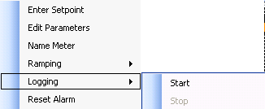 | Logging can be started in either of two ways.  1) Right clicking on the face of the meter to log brings up a context menu from which the menu option Logging -> Start Logging can be selected.  2) From the applications main menu bar, select Start Logging from the Logging menu.
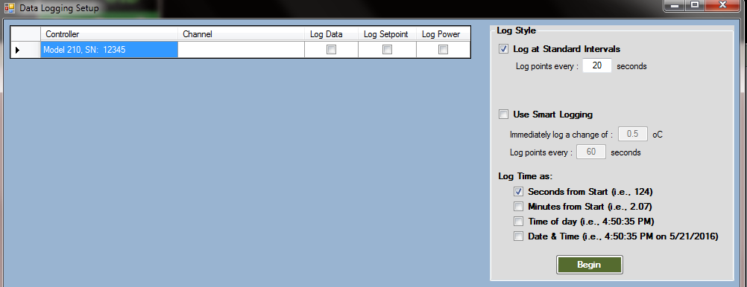 |  | The request to start logging brings up the Data Logging Setup screen. The screen shows each connected controller, and meter. Note, if a multi-channel controller, like an Apollo or Gemini is connected, both digital meter channels are shown on separate lines. For multi-channel controllers, one or all channels can be logged.
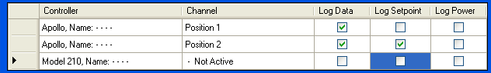 |  | The table in the Data Logging Setup screen shows each connected controller. If the controller is connected, but not powered on,
then “Not Active” appears in the channels description. To select a meter to log data, place a check the box titled Log Data on the table line associated with the meter. Selecting Log data means that time and sensed temperature data will be logged to disk for that meter. Placing a check in the box titled Log Setpoint also causes the setpoint for the selected meter to be logged, which is useful during setpoint ramping programs. With controllers that have the ProMode Upgrade enabled (see next section), there is an option to log the percent power that the controller applies to the heater in real-time. This feature is useful to detect endothermic and exothermic processes.

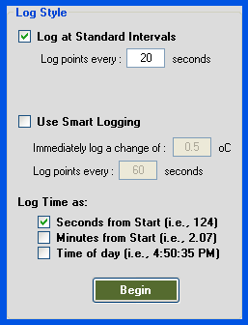 | There are two logging methods, 1) Standard Logging, and 2) Smart Logging.  Standard Logging - Standard logging instructs the software to record a data point at the interval specified in the box titled “Log points every _____ seconds.”  Smart Logging – Smart logging is a process that records a new data point only when a large enough change in temperature or pressure justifies logging a data point. When Smart Logging is selected, a data point is logged anytime a significant temperature change occurs, or a set period of time expires. Enter the maximum time period between logged data points in the “Log points every _____ seconds” text box. Second, enter the temperature change that forces a data point to be logged in the “Immediately log a change of _____ ºC” text box. Do not enter a value below 0.2º C since changes smaller than this are normal. If logging data from a vacuum regulator, the text on this screen changes and prompts for pressure value in units of mmHg (or torr).
Comparison of Normal and Smart Logging

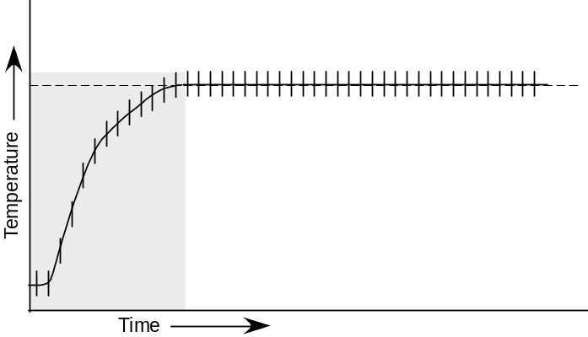  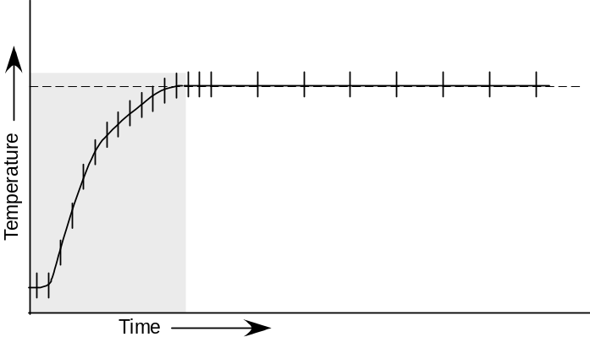 | It’s not always necessary, or desirable, to log data points at specific time intervals. For example, consider this plot.  During the initial stage of heating it’s desirable to log data points at short, regular intervals (crosses on the plot) in order to define the shape of the heating curve. But after the reaction stabilizes at the setpoint temperature, rather than logging points at short intervals, which generates large data tables, it probably is better to log data at longer intervals such as every 1 minute or 5 minutes as shown in the second plot.
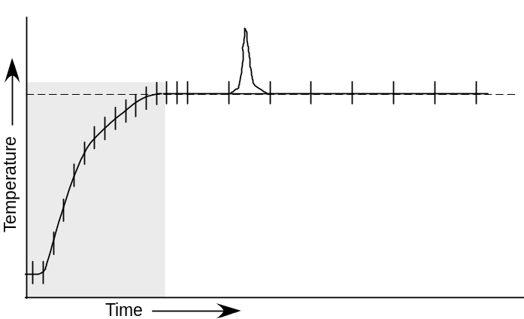  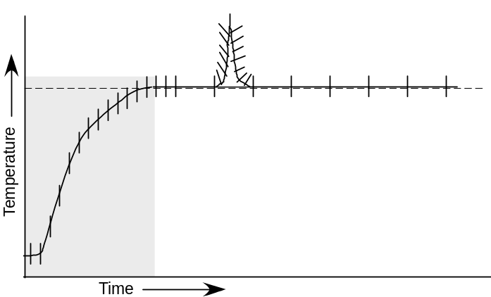 | The danger of logging data points at long intervals is that a sharp change in temperature may be missed because it occurred between logged points. Smart logging address this issue by allowing the user to set two parameters. First the user sets the maximum time period between logged points and, second, sets a log on temperature change value. If the sensed temperature changes by the temperature change value for any reason, this forces a data point to be immediately logged.  With smart logging on, the shape of the temperature spike is perfectly defined because a data point is logged every time the sensed temperature changed by the temperature change value. After the sensed temperature stabilizes, data is logged at the longer timer interval. Smart logging provides the best balance between defining the shape of a heating profile and keeping log files to a manageable size.

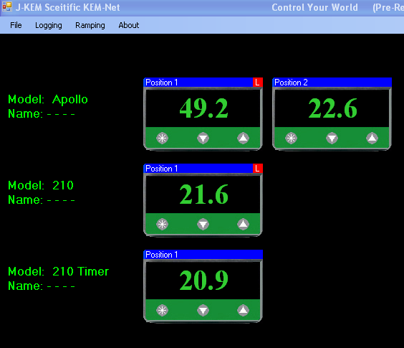 |  | When a meter is logging data, the letter “L” appears on the meters title bar.
 | Once logging has started for any meter, logging can be initiated for additional meters by right clicking on the face of the meter of interest, then from the popup menu select ‘Start’ from the Logging option.
Logging can be stopped for an individual meter my right clicking on the face of the meter, then selecting Logging -> Stop from the popup menu.
Logging can be stopped for all meters by selecting ‘Stop’ from the Logging menu on the top, main menu bar.

ProMode Enabled Controllers.

Three optional features of KEM-Net can be enabled by upgrading to KEM-Net ProMode. The first feature allows data (time, temperature, pressure, power) to be logged to a GMP compliant (21 CRF, Part 11) data file The second feature enables logging the percent power applied to the heater as a function of time, which is useful to monitor and record reaction endo- and exotherms.
The last feature graphs the power applied to the heater in real-time. Again this is useful to monitor for an exothermic reaction (see graphing section).

ProMode is enabled by obtaining an upgrade key from J-KEM, call for current pricing.
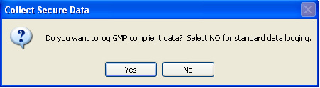 | If a ProMode enabled controller is detected, before logging begins, the system asks if you want to collect GMP compliant or non-compliant data. From the user’s perspective, there is little difference between collecting GMP compliant and non-compliant data. GMP compliant data embeds encryption keys in the data file that requires a slightly more intensive data collection process. Also, GMP compliant data collection requires the user to log into the KEM-Net system.
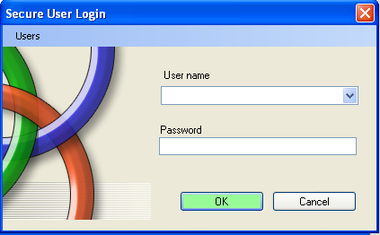 | When GMP compliant data logging is selected, the user is prompted to enter their user name and password.  New users can be added by selecting the menu option “Add New Users” from the Users menu.  Existing users can be deleted by selecting the menu option “Delete Users” then following the on-screen instructions.
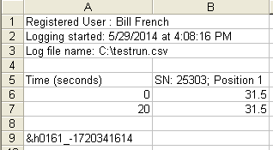 | A GMP compliant data file is a standard ‘.csv’ file that has encryption keys attached to the end of the file. The data file is readable by Excel as any other ‘.csv’ file is, but this original data file must not be modified in any way, or it will no longer evaluate as an unmodified, original data file. J-KEM recommends that you always make a copy of this file and only work on the copies, never the original file. Adding so much as a single space to the original file will conflict with the encryption key and the file will no longer evaluate as being “unmodified”.
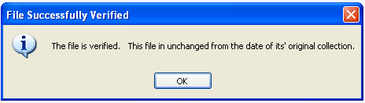 | A data file collected with GMP compliance can be tested to see if it has been modified since being originally saved. From the main form, select Verify Logging File from the Logging menu. You will be prompted to located the data file. Once located, KEM-Net evaluates the file to see if it has been modified from its original form. The results of this evaluation are posted on-screen.

Ramping

KEM-Net provides for a 16-step temperature or pressure ramp of each connected meter. A ramp in one meter runs independently of the ramp in all other meters.
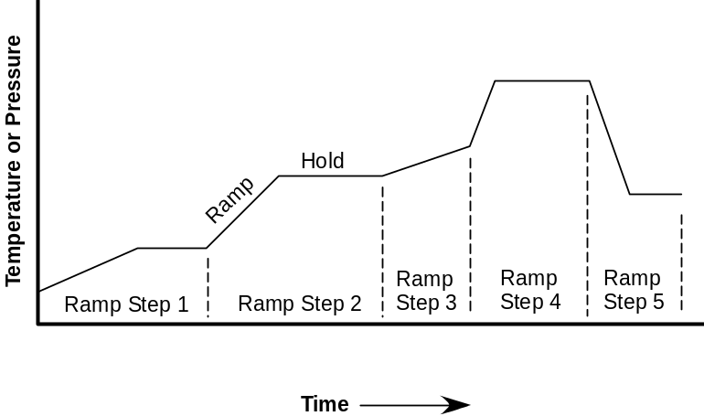 |  | A single ramp step consists of a ramp segment and a hold segment. The ramp segment is the portion of the step that changes the setpoint from one value to a second value over a set period of time. The hold segment is that period of time when the ending setpoint of the ramp segment remains unchanged.  A hold segment can have a value of 0, a ramp segment cannot. In the plot at the left, steps 1, 2, 4, and 5 have ramp and hold segments. Step 3 has only a ramp segment. Ramps can be both
positive as in steps 1-4 and negative, as in step 5. It’s important to note that entering temperatures and ramp rates for a particular step does not guarantee that the reaction temperature or pressure will follow the curve defined by the ramp step. In the case of a temperature controller, the reaction may not heat or cool as fast as the ramp segment calls for. In like fashion, a vacuum regulator may not be able to evacuate a large chamber at the rate specified by a ramp step. The rate of heating and cooling is a function of the power of the heater and the configuration of the reaction setup. For example, if a ramp step is entered from 50º C to 150º C in 10 minutes, the digital meter will change its setpoint according to the entered ramp, but whether the reaction actually heats according to the entered ramp depends on the power of the heater. If the heater is under-powered, it might take 30 minutes to heat from 50 - 150º C, but if the heater is adequately powered, then the reaction temperature will track the ramp setpoints. Additionally, entering a negative ramp step for a temperature controller (i.e., Step 5) does not guarantee that the reaction will cooling according to the entered ramp. Unless some special provision is made, temperature controllers have no active means to cool a reaction. The rate of cooling is determined by the rate of radiation heat loss and, therefore, may not correspond to the values entered for a cooling ramp step.
In like fashion, a vacuum regulator has no means to increase pressure inside of a regulated chamber. Any increase in pressure must occur by leaks in the vacuum system, or by some other means setup by the user.
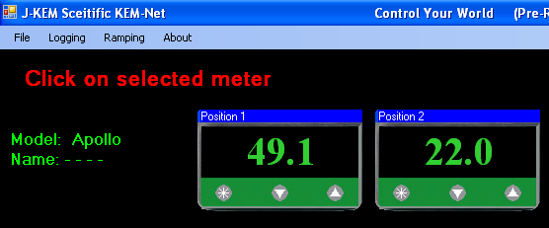 | There are two ways to create a ramp. The first is to click on the Ramping menu, then select Create Ramp. With this option, the interface prompts the user to identify the meter to create a ramp for by clicking on the face of the meter of interest. The second method is to right click on the face of the meter of interest, then from the popup context menu, select Ramping -> Create Ramp. Either way, the Ramp Builder screen appears.

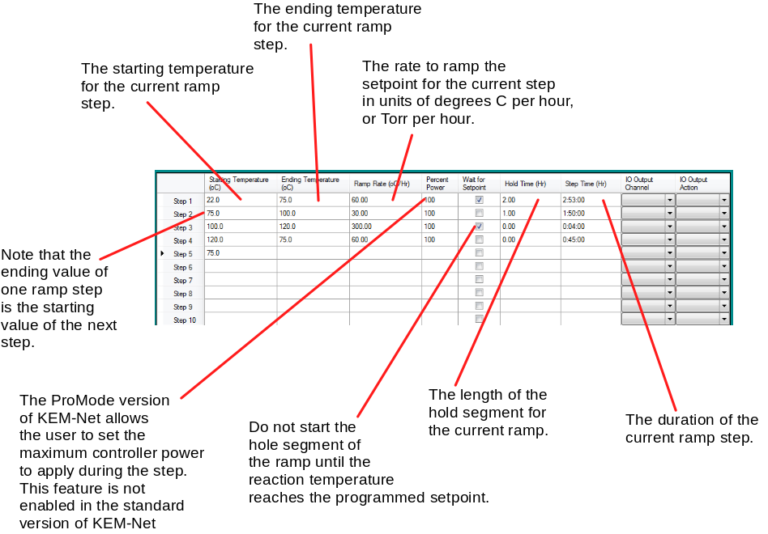 |  |  |  |  |  |  |  | Ramp Builder appears as a table with 16 blank ramp steps. As data is entered for each ramp step, the duration of the individual step, and the duration of the total ramp program are updated.
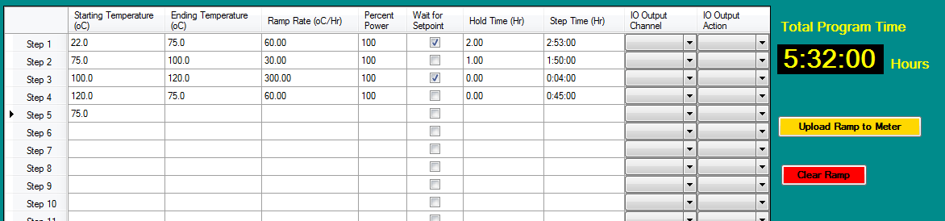 |  |  |  |  | A ramp program can consists of as few as 1 ramp step and as many as 16. Before a ramp program can be run, it must be uploaded to the meter by clicking the Upload Ramp to Meter button. Once a ramp is uploaded, it remains resident in the meter until it is overwritten by another ramp, or KEM-Net is exited.
Wait for Setpoint Feature
If this box is checked, the ramp program will not advance to the next step until the process temperature reaches the ending temperature for the step. As an example, suppose a ramp step specified to heat a process from 20 to 80C at a rate of 5C/min. If the heater for the process had sufficient power to heat the process at this (high) rate, then there would be not issue, because as soon as the setpoint ramped to 80C, the process temperature would be 80C, and the ramp could proceed to the next step. But if the heater only had enough power to heat the process at a rate of 3.5C/min, then the controller would ramp its setpoint from 20 to 80C in 12 minutes (i.e., 5C/min), but because the heater only has enough power to heat at a rate of 3.5C/min, then the actual process temperature would be 62C. If the Wait for Setpoint box is checked, the ramp program will not advance to the next step until the actual process temperature reaches the current steps Ending Temperature. If the Wait for Setpoint box is not checked, then the ramp program advances to the next step as soon as the controllers setpoint is electronically ramped to the ending temperature, no matter what the solution temperature is.
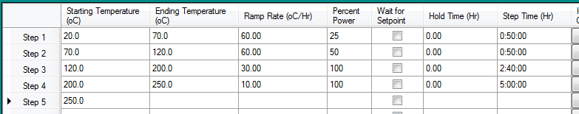 |  |  |  |  |  | Percent Power Feature  This feature is only enabled in the ProMode version of KEM-Net.  There are cases where it is not desirable to heat with 100% of the heaters power.
For example, consider the ramp program above when a process temperature ramps from 20 to 250C. During the early stages of the ramp (20 – 70C step), if 100% of the heaters power was used, this would result in large overshoots of the desired temperature, but during later states of the ramp (120 – 200C) the process would require 100% of the heaters power at these elevated temperatures.
KEM-IO
The actions of optional KEM-IO output channels (see later in the manual) can be made part of a ramp program. Simply specify the channel to act on, then the action to take (turn the output On or Off).
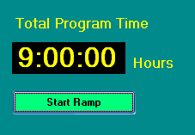 |  | An uploaded ramp is started by clicking on the Start Ramp button. Alternately, Ramp Builder can be closed without starting the ramp. In this case, the ramp remains resident in the meter and can be begun at a later time by right clicking on the face of the meter, then from the popup context menu select Start Ramp from the Ramping option.
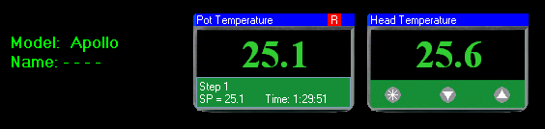 |  |  |  |  |  |  | When a meter is actively running a ramp, a red “R” appears in the upper right portion of the meter face.
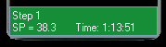 |  |  | The green panel at the bottom of the meter displays information about the current ramp step. The panel shows the step number, set point, and time remaining in the step. The time displayed is the sum of the time for the ramp segments and the optional hold
segment.. If a meter is ramping, and the controller is disconnected from the PC’s USB network, the ramp continues to advance in the PC program, even though the controller is not physically connected to implement the ramp. If the controller is reconnected within 30 seconds, the meter will pick up the ramp at its current point. If the meter is disconnected for more than 30 seconds, the ramp is cancelled.
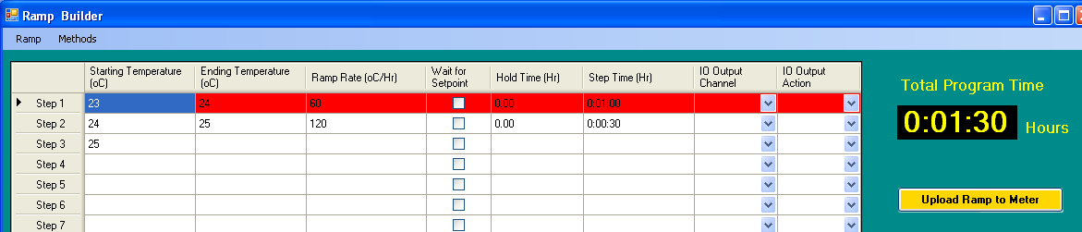  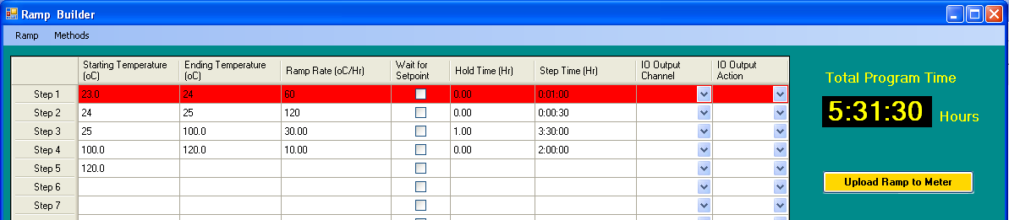 |  |  |  | A ramp in progress can be examined and edited by selecting Create Ramp either from the Ramp menu, or by right clicking on the meter of interest. Steps that are complete, and the current ramp step cannot be edited and are highlighted in red. Steps that have not started can be edited, and new steps can be added. To save the edited ramp program, click on the Upload Ramp to Meter button.
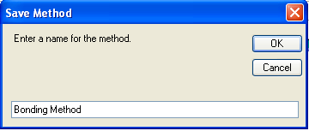 |  |  |  | Saving and Recalling Methods from Disk  Ramp methods can be saved and recalled from the PC hard drive. To save a method, select Save Method from the Methods menu. A screen appears that prompts for a method name, enter a suitable name, then click the OK button.
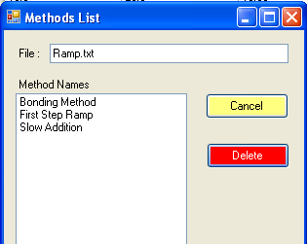 | A saved method can be recalled by selecting Recall Method from the Methods menu. From the list of methods that appears, double clicking on the desired method recalls that method and populates all three of the Ramp Builder tables with the saved data.  To delete a saved method, select Recall Method from the Methods menu, which results in a list of all methods appearing. Highlight the method to delete by single clicking on the method name, then click the Delete button. When done deleting methods, click the Cancel button or the close box.

Ramping Options:

Create Ramp - Using the main menu, select Create Ramp from the Ramping menu, then click on the meter to program the ramp into. Alternately, right click on the face of the meter to create the ramp for, then select Ramping -> Create Ramp from the popup menu.

Start Ramp – Once a meter has a ramp programmed and saved, it can be started by selecting Start Ramp from the Ramping menu, then clicking on the meter of interest. Alternately, you can right click on the meter of interest then select Ramping -> Start Ramp.
Pause Ramp – An active ramp can be paused by selecting Pause Ramp from the Ramping menu. Alternately, you can right click on the meter | 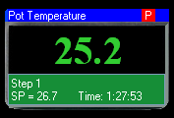 | When a ramp is paused, a red “P” appears in the upper right portion of the meter. A paused ramp can be resumed by selecting Pause Ramp from the Ramping menu, then clicking on
of interest then select Ramping -> Pause Ramp. | the meter of interest. Alternately, you can right click on the meter of interest then select Ramping -> Resume Ramp. A paused ramp is resumed at the point in the ramp where it was originally paused.
Cancel Ramp – An active ramp can be canceled by selecting Cancel Ramp from the Ramping menu, then clicking on the meter of interest. Alternately, you can right click on the meter of interest then select Ramping -> Cancel Ramp. When a ramp is canceled, it can be restarted from the beginning of Step 1 by selecting Start Ramp.
Advance to Next Step - An active ramp, or a ramp that is paused, can be advanced to the next step (advancing to the next step releases a Paused program). If the controller is running a ramp segment of the current step, then selecting this option advances the program to the hold segment. If the hold segment has a time of 0, then the program advances to the ramp segment of the next ramp step. If the current step is in the hold segment, then this option advances to the next steps ramp segment. If the controller is running the last ramp step, then advancing to the next step terminates the ramp.
When a ramp completes, or is cancelled, the red “R” in the upper corner of the meter disappears. Even after a ramp completes, the ramp program remains in the meter. The ramp can be recalled into the Ramp Builder screen by selecting Create Ramp from the Ramping menu, then clicking on the meter of interest, or right clicking on the face of the meter and selecting Ramping -> Create Ramp from the popup menu. When the ramp is recalled into the Ramp Builder screen, it can be modified or repeated without modification. Alternately, the ramp can be rerun by selecting Start Ramp from the Ramping menu, then clicking on the meter of interest, or right clicking on the meter, and selecting Ramping -> Start Ramp from the popup menu.

Graphical Display

KEM-Net provides real-time graphical display on both the main program tab, and on a dedicated Graphing program tab. The only difference between the two tabs is that the main program tab can display data from six meters, while the graphing program tab can display 12 meters.
The graph on the main screen adjusts its size to accommodate additional controllers as they are added to the system. When the size of the graph on the main program tab becomes too small, it is removed from the form and graphing is only available on the Graphing program tab.
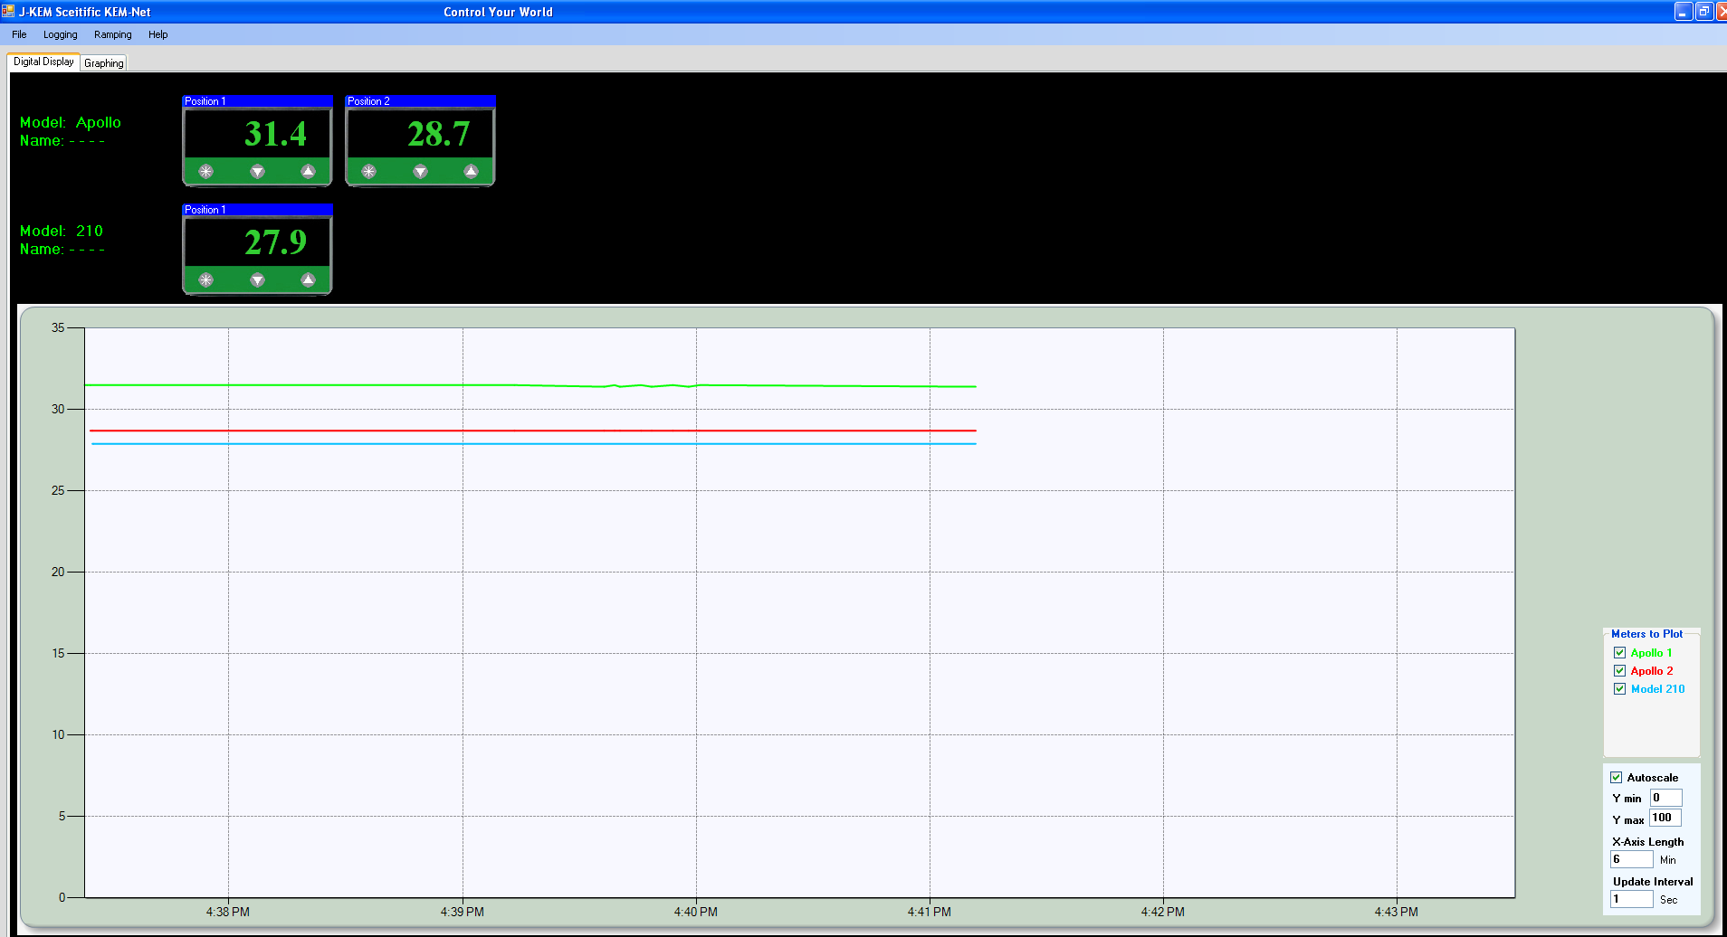  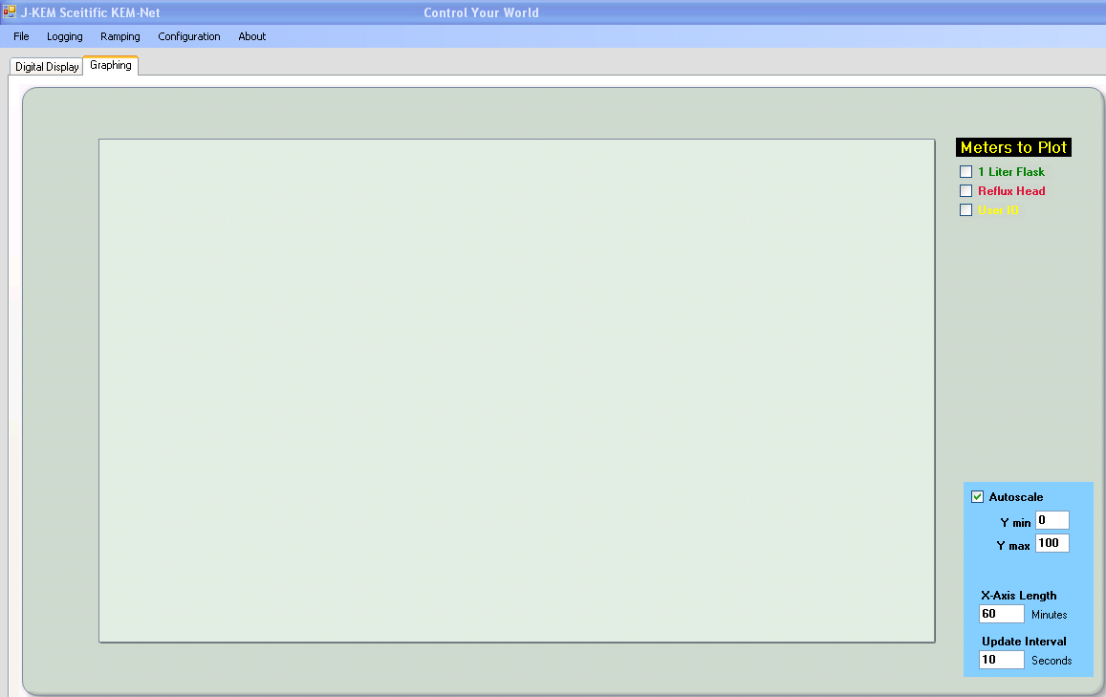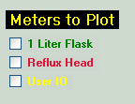 |  |  | The controls are the same for the graph on the main program tab and on the graphing program tab, and the user can select either graph to observe. The graphing screen displays the first 12 connected meters, and any name associated with the meter. As new controllers are connected, or connected controllers are removed, that list of available meters updates.
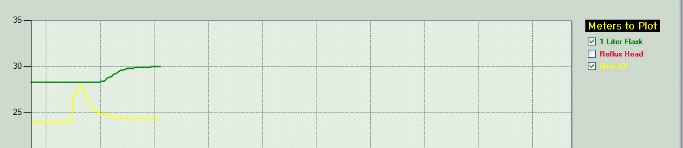 |  |  | To start graphing, place a check mark in the box for each meter to graph.
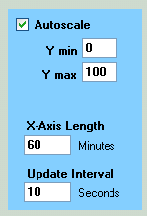 | Both the Y-axis and X-axis scales default to standard values, but can be changed by the user.
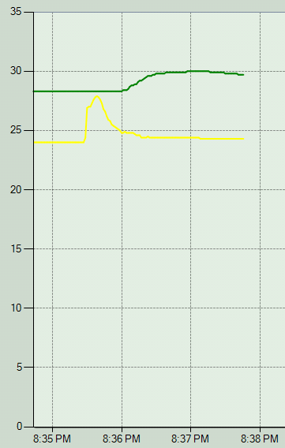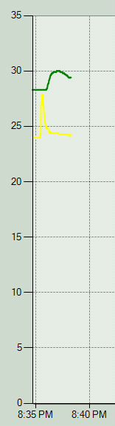 |  | The user can change the X-axis scale by specifying either a shorter (smaller X-Axis Length) or a longer (larger X-Axis Length) axis. The effect of this can be seen in these two plots.
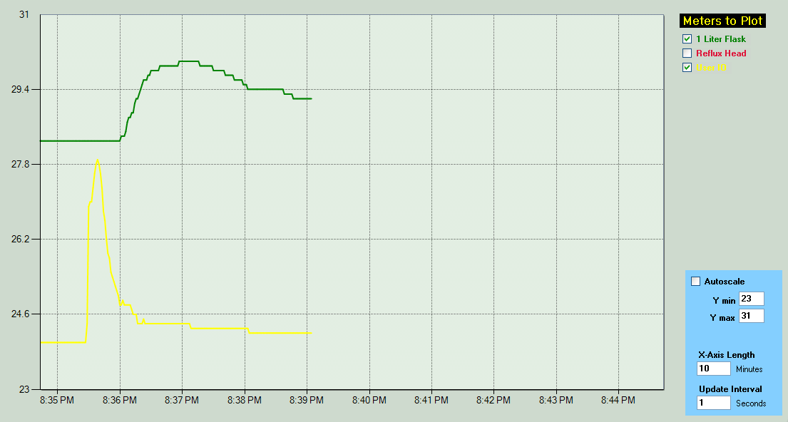 |  |  |  | When the check box Autoscale is checked, KEM-Net selects a Y-axis scale that's appropriate for the data being plotted. The user can uncheck Autoscale and enter the lower and upper value of the Y-axis scale. The effect of autoscale and manually specifying Y-axis minimum and maximum values can be seen by comparing these two plots.
KEM-Net Pro Charting Features
ProMode allows the user to graph reaction temperature and optionally the power applied to the heater. The benefit of graphing power is that an endo- or exotherm that would not be detected by graphing only temperature is easily detected when Percent Power applied to the reactor is graphed.
For example, in the plot below, the setpoint of the controller is set to 80.0 C. During the initial stages of heating (yellow region), the controller applies 100% power to the heater to cause the reaction to heat rapidly. As the reaction temperature approaches the setpoint temperature (green region) the controller adjusts the percent power applied to the heater so that the reaction temperature reaches and then stabilizes at the setpoint. At some point in the reaction, an exotherm occurs (red region), which is seen as a short increase in reaction temperature. The increase is slight enough that it could be mistaken for a short loss of regulation by the temperature controller. But by looking at the power applied to the heater, the exotherm is immediately apparent. The temperature controller detected an increase in temperature above the setpoint and in response decreased power to the heater, in this case to 0%. The effect of the controller lowering power to the heater to minimize the rise in reaction temperature (this is what the controller is supposed to do), has the effect of masking the true extend of the exotherm that occurred.

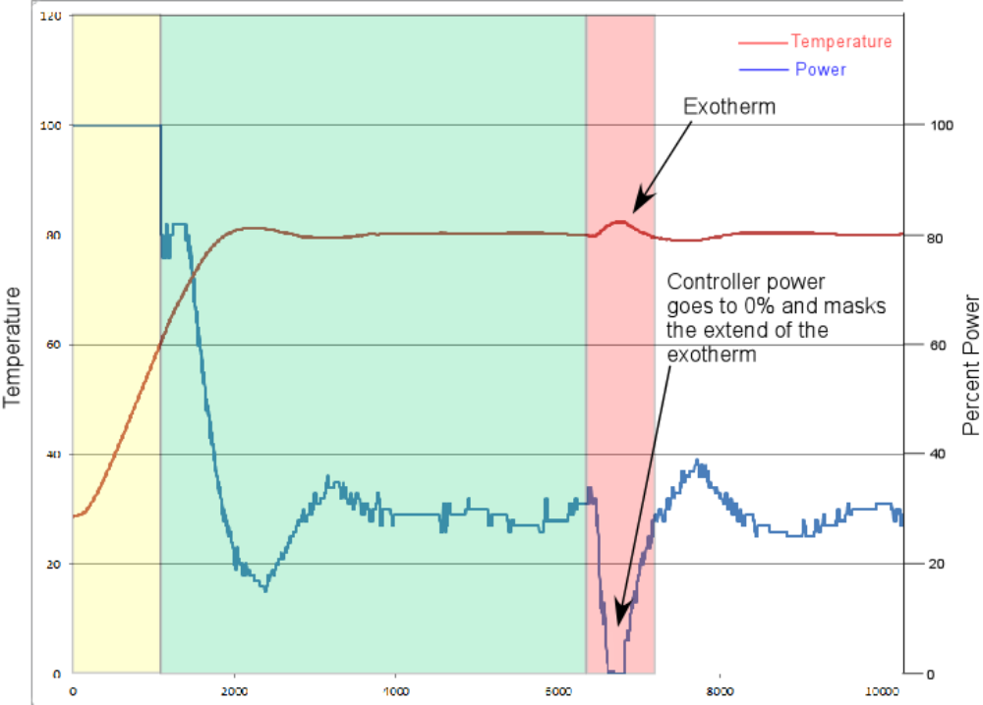

Any controller can be upgraded to ProMode by entering an Upgrade key (supplied by J-KEM) at a cost of $75.00. Contact J-KEM for more information.
Controlling User Inputs and Outputs

KEM-Net has been enhanced to support the new feature of User configurable Input and Output events. The new IO feature allows a chemist to turn other instruments (chillers, stirrers, motors) On/Off as a function of time, temperature or other input event. For example, KEM-IO allows a chemist to construct a program that accomplishes a program like this:

Turn on my stirrer, then ramp my reaction from 25º C to 100º C if 45 minutes, hold for 2 hours, then turn off heating. When the reaction cools to 50º C, turn off the stirrer. If any at any point the reaction exotherms and heats above 110 ºC, turn on my chiller and keep it on until I manually reset the system.

Note that optional User IO is distinct from, and has nothing to do with, the heater power outlet on the front of every temperature controller. Optional User Inputs and Outputs must be order as an option and do not appear on a standard controller unless it has been ordered. Contact J-KEM for information.
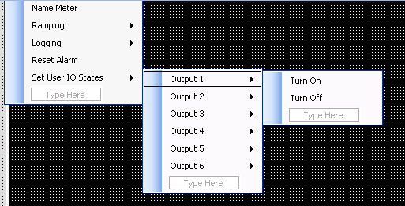 | The easiest way to control optional Outputs installed on a controller is by right clicking on the face of the meter, then selecting the Set User IO States, select the Output to change, then select if the output should be On or Off.  The following discussion explains how the action of Outputs and inputs can become part of a temperature controller program.
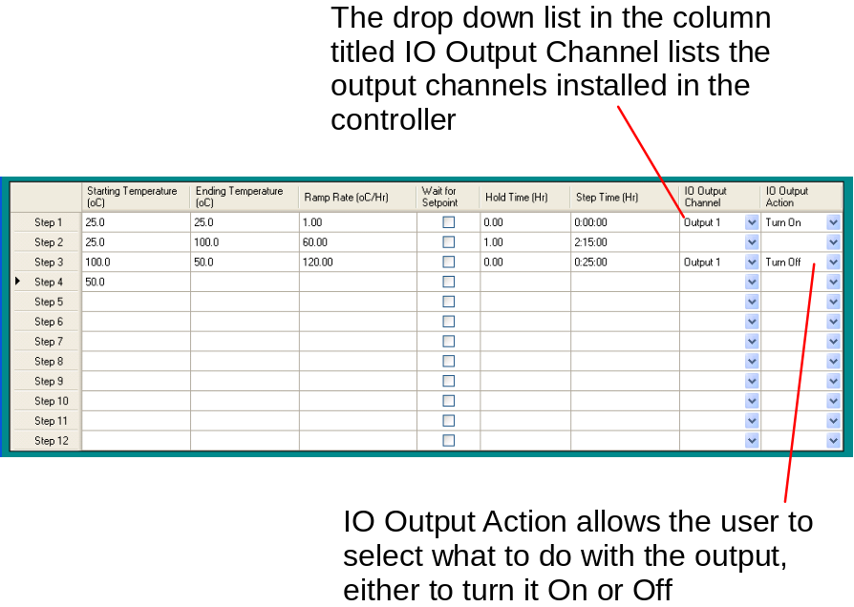 |  | The actions of user IO are configured in three panels presented on the Ramping screen. The first panel, the standard ramp table allows the actions of Outputs to be controlled as a function of time. As an example, consider what each step in this table would accomplish.  Step 1 – When the ramp starts, the setpoint of the controller is set to 25 ºC and outlet 1 is immediately turned on (outlet 1 could control a stirrer, for example). The action of the user IO (turn outlet 1 on) happens immediately because the step has a Step Time of 0.0 hours. Step 2 – The setpoint of the controller ramps from 25 ºC to
100 ºC in 1 hours and 15 minutes followed by a hold time of 1 hour.
Step 3 - The setpoint is then lowered from 100 to 50 ºC in 25 minutes, then outlet 1 is turned off. Note, the state of on outlet changes at the end of the current step. If the step has a hold time, then the outlet changes state at the end of the hold.

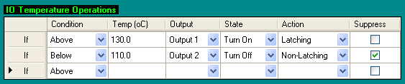  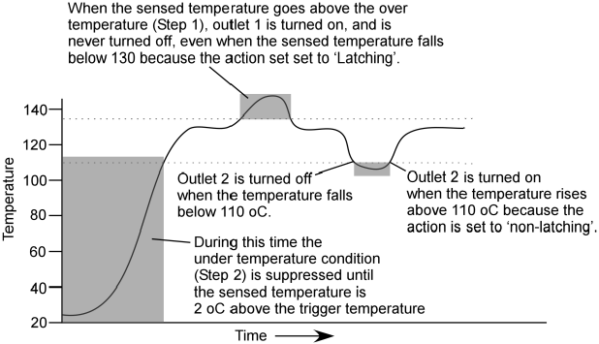 | The second panel that controls User IO is the IO Temperature Operations panel. This panel allows the user to specify how an outlet responds to a change in temperature. For example, the table at the left will turn outlet 1 on if the temperature of the controlling meter rises over 130 ºC and turn outlet 2 off if temperature falls below 110 ºC. The temperature plot below shows how User Outputs will respond to changes in reaction temperature.  Following is an examination of each component of an IO Temperature Operation.  Condition (column 1) – The user can specify if the output should respond when the sensed temperature is above or below the action temperature (in column 2).  Action Temperature (column 2) – A user entered temperature at which the output should respond.
Output (column 3) – The optionally installed output to respond to a temperature condition.
State (column 4) – The state that the output should go to, either On or Off.
Action (column 5) – This specifies whether an over or under temperature condition is resettable or not.
An action of Latching means that if the conditions occur that cause the output to change states, the output never resets itself, even after the alarm condition no longer exists. A Non-Latching action means that the output sets itself to the user entered state when the alarm condition exists, but resets itself when the alarm condition no longer exists. For example, in the table above, if the sensed temperature rise to 130 ºC, output 1 will turn on. When the sensed temperature falls below 130 ºC, Output 1 stays on, and never resets itself because the Action is set to Latching. Also, from the table above, if the sensed temperature falls below 110 ºC, Output 2 will turn off. If the sensed temperature later rises above 110 ºC, Outlet 2 turns back on. Latched outputs require the user to turn the temperature controller off AND disconnect the controller from the USB port to reset the alarm. Non-latched outputs reset them self when the alarm condition no longer is present.
Suppress (column 6) – This option is enabled only for Under temperature conditions. The reason to suppress an under temperature condition can be seen from the plot above. If the reaction starts heating from room temperature, the under temperature action (i.e., turn Output 2 Off) would trigger immediately, because room temperature is below the trigger temperature of 110º C. When Suppression is enabled, evaluation for an under temperature condition does not start until the sensed temperature is 2º C above the under temperature value, in this case, evaluation for an under temperature condition will not start until the sensed temperature is 112º C. If it's desirable for the under temperature action to start, even during initial heating, then leave the Suppression option unchecked.

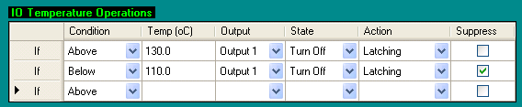 | The features in the IO Temperature Operations table can implement a very desirable safety feature called a "Band Alarm". Suppose you wanted to heat a reaction to 120º C, consider how the table at the left would protect against almost any heating accident. During initial
heating, the under temperature section of the table (line 2) is suppressed, so Output 1 is On. Once the solution temperature reaches 112º C, the under temperature section is enabled. Now, from this point forward, if the reaction temperature exceeds 130º C or falls below 110º C, Output 1 is turned off until being manually reset. The over temperature section (line 1) protects against an exothermic reaction or a heater or temperature controller malfunction, and the under temperature section (line 2) protects against a burnt out heater, a broken flask, or a thermocouple that fall out of the flask an onto the floor.
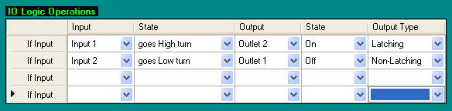 | The third panel that controls User IO sets the state of Outputs as a function of Inputs. For example, you might have an experimental setup where you want the controller to wait until an injection, or some other event occurs before turning On (or Off) an output, or setting a new setpoint temperature into the controller
(implemented in the next version of KEM-Net).

Editing Meter Parameters

Each digital meter contains a set of internal parameters that determine how the meter operates. These parameters are stored in the digital meter itself, and not the KEM-Net software, and are saved to the meter, even when the meter is turned off. Some of the parameters simply control the user interface, for example, whether the meter displays temperatures in degree centigrade or Fahrenheit, but others control how the instrument itself operates, so for this reason, only users that understand the affects of each operating parameter should enter the controller’s editing screen.

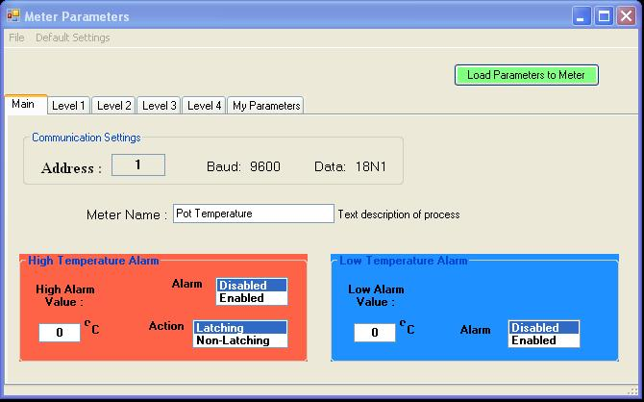 | A meter is placed in programming mode by right clicking on the face of the meter of interest, then from the popup menu selecting “Edit Parameters”. The parameter screen for the selected meter appears and populates with the meters current programmed values.  The parameter screen has six levels, corresponding to the six tabs on the form.  Functions on the Main programming level:
File Menu – The only option is to Exit the parameter screen. If changes have been made on any level of the form, and have not been saved, you are prompted to save parameters before exiting.
Default Settings Menu – The only option in this menu is ‘Load Meter Defaults’. Selecting this option loads J-KEM’s default parameters for your controller. For temperature controllers, the default tuning set is the set appropriate for heating mantles and most other laboratory heaters. See the controller’s User manual for additional information.
Address – The address of the meter cannot, and should not be changed. The address of the meter corresponds to its channel number on the controller.
Meter Name – A descriptive name, like “2 Liter Reactor” or “Head Temperature” can be associated with the meter. This name appears in the top green bar of the digital meter, and is saved and recalled every time the meter is connected.
High and Low Temperature Alarms – Alarm features are explained in the next section.
High and Low Temperature Alarms

Safety Notice: High and Low Temperature alarms should only be used by a trained professional who understands how these alarms work. These alarms are a software feature and are NEVER a substitute for a hardware safety backup for a heated reaction. The alarm features of KEM-Net are a convenience, but because they are software based, they cannot be used as a safety backup for an over or under temperature condition in a monitored reaction. J-KEM Scientific sells a Lab Safety Monitor and our Model 270-Style Safety Controllers for hardware safety backups.
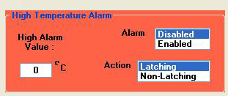  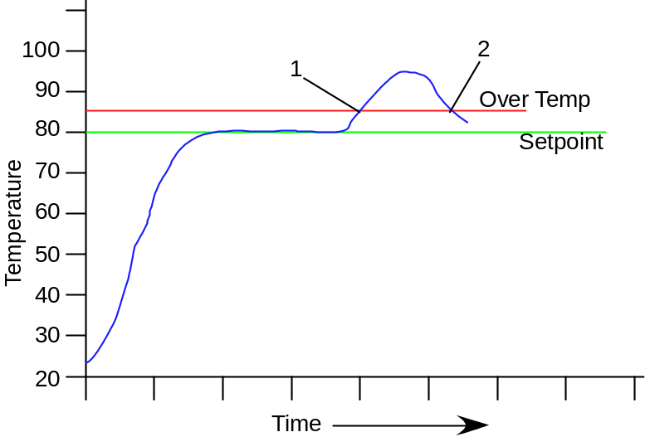 | High Temperature Alarm –  This is a software alarm, i.e., part of the KEM-Net software and is not stored to the digital meter. A high temperature alarm turns power off to the heating outlet in the event that the sensed temperature exceeds the user entered High Alarm Value. To program a high temperature alarm, enter the High Alarm Value (i.e., the temperature that will trigger an alarm if it’s exceeded) in the text box provided, then click “Enabled” in the Alarm selection box. The high temperature alarm is not active, or running, until Enabled is clicked.  If a high temperature alarm were to trigger (because the sensed temperature reached or exceeded the High Alarm Value), power is removed from the heating outlet (important: see ‘How Power is Removed’ During an Over- or Under-Temperature Condition, below). Once an alarm is triggered and power has been removed from the heating outlet, eventually, the sensed temperature will fall below the High
Alarm Value. When the sensed temperature no longer is above the High Temperature Alarm Value, the software can either resume heating or permanently stop heating depending on the Alarm Action that is set.
Alarm Action: Latching – If the alarm action is set to latching, once the alarm is triggered, power is permanently removed from the heating outlet until the alarm is manually reset. A latched alarm never resets itself, even when the sensed temperature falls below the High Alarm Value.

Alarm Action: Non-Latching – When the alarm action is set to non-latching, power is removed from the heating outlet when the sensed temperature reaches the High Alarm Value, and is restored to the outlet when the sensed temperature falls 0.5 degrees below the High Alarm Value. A non-latched alarm resets itself with the sensed temperature falls below the High Alarm Value.

In the plot above, both a latching and a non-latching alarm remove power from the heating outlet when the sensed temperature reaches the point labeled “1”. A latching alarm never resets, but a non-latching alarm resets the controller and resumes heating when the sensed temperature falls 0.5 degrees below the High Alarm Value, or at point ‘2’ in the plot above.

How Power is Removed During an Over- or Under-Temperature Condition
When an over or under temperature alarm is triggered, due to the sensed temperature exceeding one of the Alarm Trigger Values, the software does not directly removed power from the heating outlet, rather it changes the setpoint of the digital meter to its lowest allowed value. It’s assumed that changing the meter’s setpoint to the lowest allowed value sets the meter to a value that is low enough to stop all heating. For example, if the controller is fitted with a type T thermocouple input, during an alarm condition, the setpoint is set to –199º , if it is fitted with a type K thermocouple, the setpoint is set to -50º , and if a type J thermocouple input, the setpoint is set to 0º. If it's not true that changing the meter’s setpoint to the values listed prevent the reaction from being heated, then the over temperature alarm cannot be used.
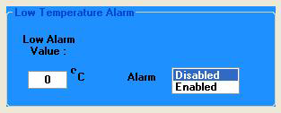  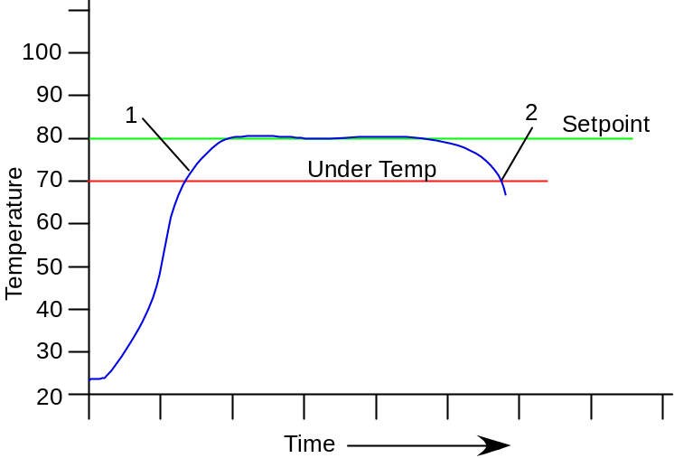 | Low Temperature Alarm –  This is a software alarm, i.e., part of the KEM-Net software and is not stored to the digital meter. A low temperature alarm turns power off to the heating outlet in the event that the sensed temperature falls below the user entered Low Alarm Value. To program a low temperature alarm, enter the Low Alarm Value (i.e., the temperature that will trigger an alarm if the sensed temperature fall below it) in the text box provided, then click “Enabled” in the Alarm selection box. The low temperature alarm is not active, or running, until Enabled is clicked.  Important: see ‘How Power is Removed’ During an Over- or Under-Temperature Condition, above.
How a Low Temperature Alarm Works – As an example, suppose that the reaction setpoint is set to 80º C and a low temperature alarm is set at 70º C. When the reaction starts to heat, it’s probably at or near room temperature. If the low temperature alarm were active at this point, the alarm would trigger, because room temperature (23º C ) is below the low temperature alarm of 70º C. For this reason, when a low temperature alarm is Enabled (i.e., turned on in the software), triggering of the alarm is suppressed until the reaction temperature rises 1º C above the Low Alarm Value. That is, even though ‘Enable’ was selected in the Low Temperature Alarm panel, the software doesn’t actually start to monitor for a low temperature alarm until the reaction temperature rises 1º C above the Low Alarm Value. Referring to the plot above, the low temperature alarm is in an intermediate “suppressed” state in the beginning of the plot and doesn’t actually becomes active until the sensed temperature reaches point “1”. Once the low temperature alarm becomes active, if the reaction temperature falls below the Low Alarm Value, power to the heating outlet is removed permanently until the meter is powered off, or the setpoint is manually changed. A low temperature alarm’s action is always “Latching”.
A low temperature alarm generally protects against a thermocouple falling out of solution, or a flask breaking. For any event where the thermocouple cools unexpectedly, it’s a safe practice to remove power from the heating outlet. As with the High Temperature Alarm, power is removed from the heating outlet by setting the meters setpoint to its lowest allowable value.

How Alarms Affect Temperature Controllers with Cooling Outlets
Both high and low temperature alarms work by setting the controller’s setpoint to the lowest allowed value. For temperature controller models fitted with cooling outlets, setting the setpoint to a low value generally has the effect of applying power to the cooling outlet. For example, suppose a Model 250 (type T thermocouple) is powering a heated reaction at 80º C, and has a high temperature alarm set for 85º C. If the sensed temperature were to reach 85º C, the alarm would trigger which sets the controllers setpoint to
-199º C. Presumably, at this setpoint, power would be removed from the heating outlet, but the cooling outlets would be powered and stay powered until the setpoint is changed or the controller is turned off. For controllers with cooling outlets, the user must ensure that it is safe to continuously power anything plugged into the cooling outlet.
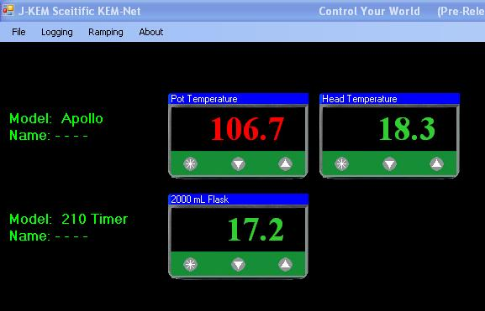 | When either a low or high temperature alarm is triggered, the color of the temperature display in the affected meter changes from green to red. If the alarm is set to non-latching, when the temperature falls to the point where the alarm resets, the temperature display turns green again.
Parameter Levels 1 to 4

It’s beyond the scope of this software manual to explain the meaning of each of the parameters in the J-KEM digital meter. All parameters shown in these screens are stored in the meter and can also be accessed by physically placing the digital meter into its programming mode by means of the buttons on the front panel of the meter (not by using the software). For safety reasons, the Parameter screens don’t allow the user to change select parameters. Only a professional qualified to understand the effect of changing the meters operating parameters should change these values.
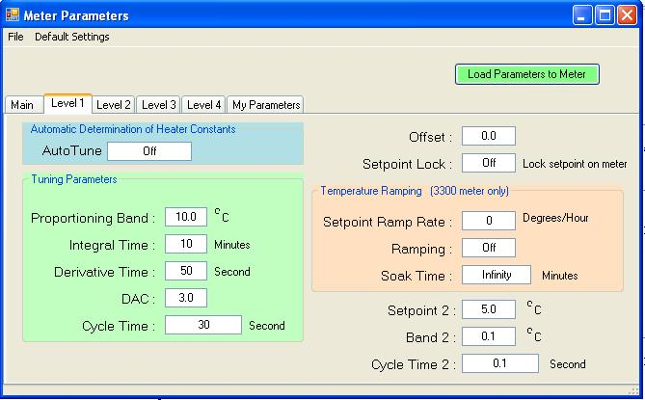 | Autotune – Autotune is an automated routine that matches the PID control characteristics of the controller to the heating characteristics of the heater. See the Section Two in the User manual for more information.  Proportional Band, Integral Time, Derivative Time, and Cycle Time are the PID parameters of the controller. These parameters affect how the controller applies power to the heater.  Offset – is generally not used and should remain at a value of 0.0.  Setpoint Lock –Turning setpoint lock on prevents the meter’s setpoint from being changed by pressing the physical buttons on the face of the digital meter
Ramping Controls – These controls use the ramping function built into the Model 3300 meter to control a single step ramp. Note that this is distinct from the multi-step software ramp that KEM-Net provides.
Setpoint 2 Functions - These settings generally are used to control over temperature circuits built into the controllers hardware and should generally not be changed.
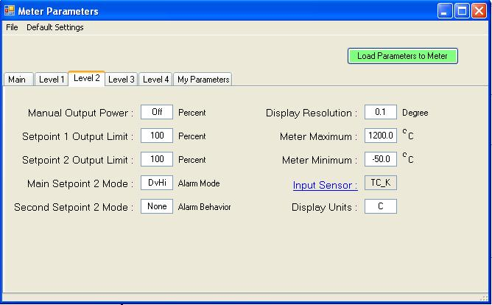 | The controls on Level 2 should not be changed, since they generally control the way any over temperature alarm circuits built into the controller operate.  Display Resolution – The controller can be placed in either 0.1 or 1.0 display resolution mode.  Meter Maximum – This is the maximum allowable setpoint temperature that the meter will accept. Setting the meter maximum to a value that prevents a dangerously high setpoint from being accidentally entered is a good safety practice.  Meter Minimum – This is the lowest allowable setpoint that can be entered into the meter.  Display Units – The controller can be configured to display temperatures in º C or º F.

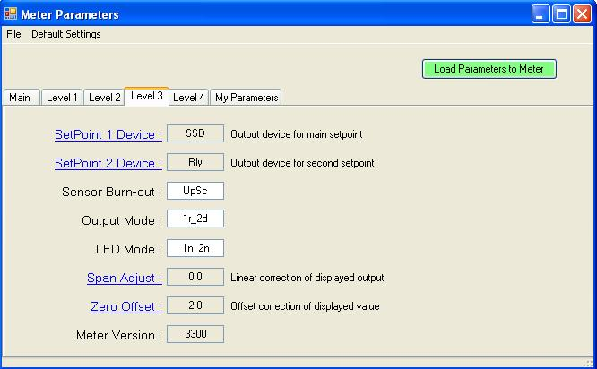 | None of the controls on Level 3 of the parameter page should be changes by anyone other than a skilled technician knowledgeable about the effect of changing any of these parameters.  Zero Offset - This is the temperature offset required for the meter to display temperatures with proper calibration. This value is entered by J-KEM and should not be changed.
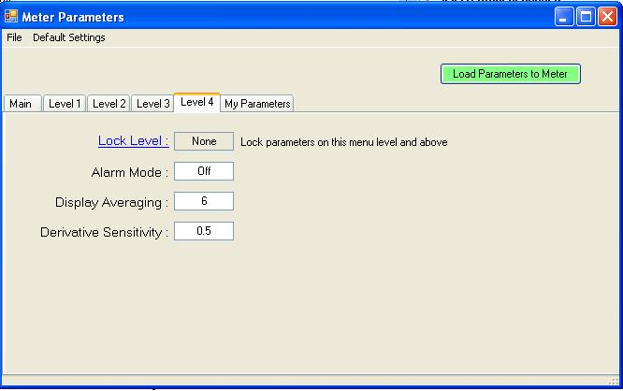 | The values of Level 4 should not be changed. These effect the way the controller measures and displays temperatures.
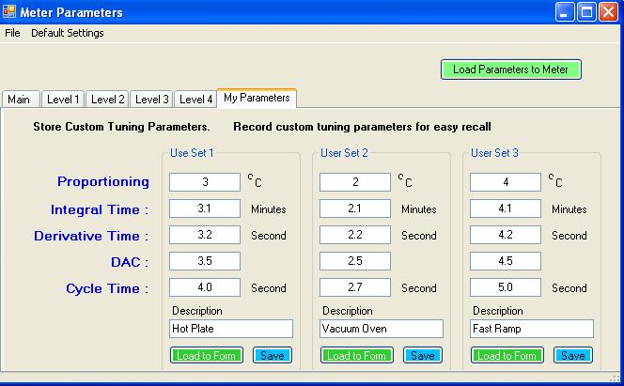 | The My Parameters tab of the Parameters form provides a place for an experienced used to store, upload, and recall custom PID parameter sets. The PID parameters of the controller affect how the controller powers the heater. The PID parameters loaded by J-KEM into the controller before shipping are the best set for most laboratory heating applications. There are many different heater styles in laboratories, all of which your J-KEM controller can regulate, but sometimes, some of these heaters need custom PID parameter sets. For example, there is an enormous difference in the heating characteristics between a vacuum oven and an IR lamp. Your J-KEM can regulate both of these devices, when it is loaded with the proper PID parameters for the device.
Text boxes are provided to store 3 unique sets of PID parameters. When a set of text boxes are filled in with custom PID parameters, they can be saved to your PC for later recall by clicking the Save button associated with that User set. Clicking the button Load to Form, loads the PID settings to Level 1 of the Parameter form. When the form is exited, the new PID values are uploaded to the digital meter.

Application Notes

Note 1 – Example of Entering a Multi-Step Temperature Ramp
J-KEM received a request from a researcher for help to set up a detailed temperature ramp in KEM-Net software. The text in blue (below) is the ramp the researcher wanted to implement, and what follows this is J-KEM’s explanation of how to enter the ramp. We hope you find this useful.

I would like to generate the ramp for my reaction as follows :

For one reaction : Temperature profile as follows :

1. Temperature from 35 deg C to 100 deg C in 60 min.
2. From 110 to 150 deg C in 90 min.
3. 150 to 180 deg C in 30 min.
4. Hold the reaction mass at 180 deg C for 60 min.
5. After holding at 180 deg C for 60 min, increase from 180 to 205 in 60min.
6. From 205 to 222 deg C in 60 min.
7. Then continue the reaction at 222 deg C for 4 hrs.

Below is how this ramp is implement using our KEM-Net software.

Step 1 35 to 100º C in 60 minutes, the ramp rate is (the change of temperature needed in 60 minutes) 65º C/hour

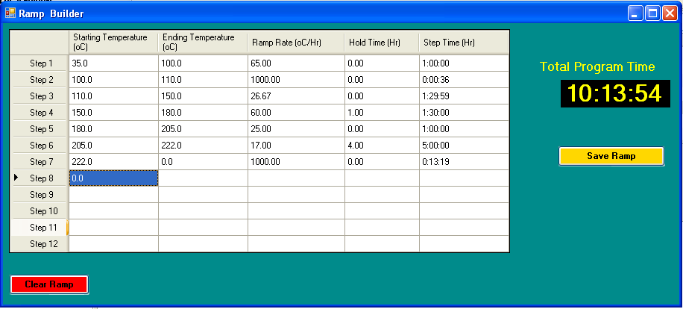

Step 2. The user requested to increase from 110 to 150º C in 90 minutes, but note, at the end of step 1 the controller is at 100º C. You cannot start step 2 at 110º C when step 1 ends at 100º C, you must add a step that ramps the controller from 100 to 110º C, using a very fast ramp. To implement this, Step 2 ramps from 100 to 110º C at a rate of 1000º C/hour. This ramp step will take 36 seconds.
It’s very important to understand that just because you change the setpoint in the controller from 100 to 110º C in 36 seconds, that doesn’t mean that the reaction will actually heat from 100 to 110º C in 36 seconds. The rate of heating is 100% dependent on the power of your heater. If you have a high power heater, then the reaction will heat fast, if you have a low power heater, then the reaction will heat slow. It’s critical to understand that a ramp program simply changes the setpoint in the temperature controller, how fast your reaction temperature changes is 100% dependent on the power of the heater.

Step 3 Now the program ramps from 110 to 150º C in 90 minutes, that is a ramp rate of 26.67º C/hr
(i.e., (150 – 110)/1.5 = 26.67).

Step 4 Now the program ramps from 150 to 180º C in 60 minutes and then holds at 180º C for 60 minutes (note that you can hold a step by entering a hold time in the column titled “Hold Time (Hr))

Step 5 ramps from 180 to 205º C in one hour.

Step 6 ramps from 205 to 222º C in 60 minutes (Ramp rate = (222-205)/1.0 = 17.0) and then holds at
222º C for 4 hours. Another important point to understand is that just because the program sets the setpoint of the controller to 222º C doesn’t mean that the reaction will actually heat to 222º C. Once again, the ability of the reaction temperature to heat to the programmed setpoint temperature is 100% dependent on the power of your heater. A ramp program simply automates setting the controller’s setpoint to the temperatures required by the ramp, but the actual reaction temperature will depend on the power of the heater.

Step 7. At the end of the program, if you want to turn your reaction “Off” simply enter a very fast ramp rate to take the setpoint to 0º C.

Now click the Save Ramp button, and then the Run Ramp button that appears.
Note 2 – Why Doesn’t the Temperature of My Process Match the Ramp Entered?

Consider the two step ramp below. In step 1, the user wants to ramp the temperature of a reaction from 20 to 70C at a rate of 5C/min. When KEM-Net runs this ramp step, it electronically changes the setpoint in
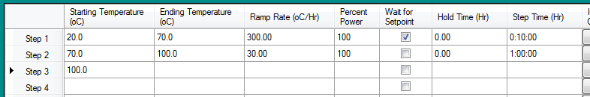

the controller at a rate of 5C/min, but that doesn’t guarantee that the temperature of the actual reaction will change at the same rate. The rate that the reaction temperature changes at is dependent, amount other things, on the power of the heater. If the heater used is powerful enough to increase the reaction temperature at 5C/min, then the rate of reaction temperature increase will match the rate of increase of the setpoint. But, if the heater does not have enough power to heat at this rate, then even though the setpoint is being changed at a rate of 5C/min, the reaction temperature will change at the rate that the heater is able to produce.

For example, consider this plot of 500ml of toluene being heated by a 1000ml heating mantle.
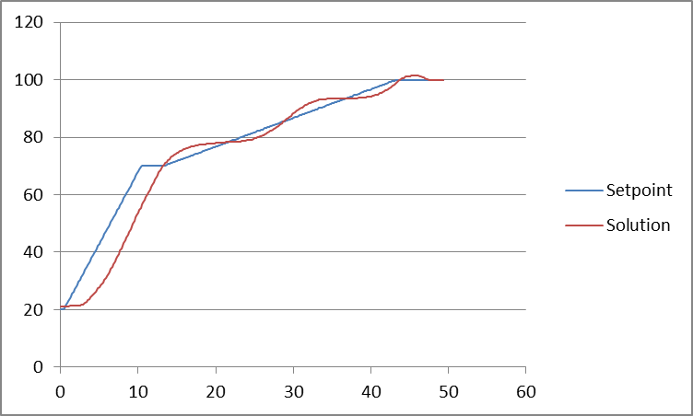

During step 1 of the ramp, the plot shows that the setpoint was ramped at a rate of 5C/min, but the solution temperature couldn’t keep up with this heating rate because heating mantles didn’t have enough power to heat at 5C/min. This plot also shows the value of using the Wait for Setpoint feature of the ramp. From the plot, the setpoint ramped from 20 to 70C in 10 minutes, but after 10 minutes, the solution temperature was only 54C. Since the Wait for Setpoint feature was selected, the ramp did not continue to Step 2 until the solution temperature reached 70C, which was at time = 13 minutes. At the 13 minute mark, the ramp continued to Step 2, which was at a rate of 0.5C/min, a heating rate the heating mantle can easily achieve.
ASCII Parameters and Protocol for User Written Code.

The USB board on your J-KEM controller implements a simple ASCII interface for users who would like to communicate with the meter using an in-house application or third party software like LabView. During normal installation, two drivers are loaded for the controller, one is for USB communications, which KEM-Net uses, and the second is a virtual COMM port driver that can be used with this ASCII protocol. Your application must open the virtual comm port created when the controller is plugged into the PC.
For single channel controllers, like a Model 210 or DVR, the address of the meter is always “1’”. For multi-meter controllers, the address of the meter is its’ “position” in the controller. For example, in a Model 270, the setpoint meter has an address of ‘1’, the over-temperature meter has an address of ‘2’. In a Quad temperature controllers, the meters have addresses 1 to 4.

Comm settings: Baud (9600), Data bits (8), Stop bits (1), Parity (None), No handshaking.

Table 1. Implemented ASCII Commands
Command | Controller Reply | Comments
T(address)\r  Example: T(1)\r  Address is the address of the meter.  The character ‘\r’ represents the control character carriage return and has the HEX value of 0x0D  All commands are case sensitive | 85.4\r | The ‘T’ command requests the controller to return the current system temperature for temperature controllers, or the current system pressure for vacuum regulators. Temperature readings are returned in units of ºC or ºF (whatever the meter is programmed for) and in the case of pressures the units are mmHg (torr).
P(address)\r  Example: P(2)\r  Address is the controller address. | 75.0 | The ‘P’ command requests the controller to return the current setpoint value. Temperature setpoints are returned in units of ºC or ºF (whatever the meter is programmed for) and in the case of pressures the units are mmHg (torr).
S(address,value)\r  Example: S(1,85.0)\r  Address is the controller address.  Value is the new setpoint value | OK\r | The ‘S’ command enters a new setpoint value in the controller. Temperature setpoints must be in units of ºC or ºF (whatever the meter is programmed for) and in the case of pressures the units are mmHg (torr). To acknowledge receive to the new setpoint, the controller replies with ‘OK\r”
Error Handling  J(address)\r  T(bad address)\r | ERROR\r  No reply | There is no ‘J’ command. If an invalid command is sent to a valid address, the word ERROR is returned.  If a valid command is sent to a non-existing address, no reply occurs.

Loading KEM-Net Drivers

Windows 8 and 10 will not automatically load an ‘unsigned driver’, and KEM-Net drivers are unsigned.
To load unsigned drivers follow the procedure below [Reproduced from www.howtokeek.com]

How to Disable Driver Signature Verification on 64-Bit Windows 8.1
or 10 (So That You Can Install Unsigned Drivers)

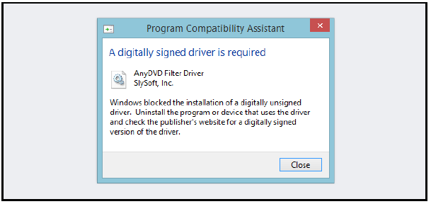
64-Bit editions of Windows require digitally signed drivers. The problem is that many devices ship with unsigned drivers. Today, we’ll show you how to install them regardless.
Digitally signed drivers include an electronic fingerprint that indicates which company the driver was produced by as well as an indication as to whether the driver has been modified since the company released it. This increases security, as a signed driver that has been modified will no longer have an intact signature. Drivers are signed using code signing certificates.

How to Disable Driver Signature Verification on 64-Bit Windows 8.1 or 10
To disable driver signature verification, we’re going to need to get into the Troubleshooting options from the boot manager. The easiest way to bring this screen up is using a secret trick.
Simply select Restart from the power options menu (on Windows 8 that’s under Charms or on the login screen, and in Windows 10 it’s on the Start Menu).
Hold down the SHIFT key while you click Restart.

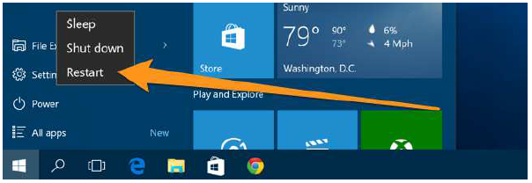
(Again, you can use this trick on any of the power menus in Windows 8 or 10, whether on the login screen, Charms
bar, Start Menu, or Start Screen)

Once your computer has rebooted you will be able to choose the Troubleshoot option. | 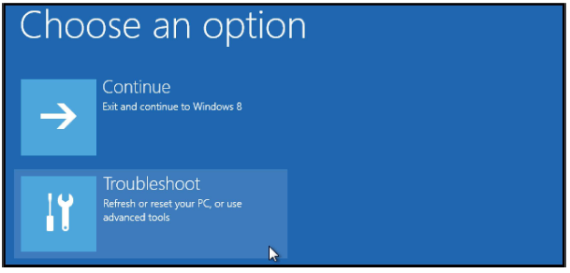
The head into Advanced options. | 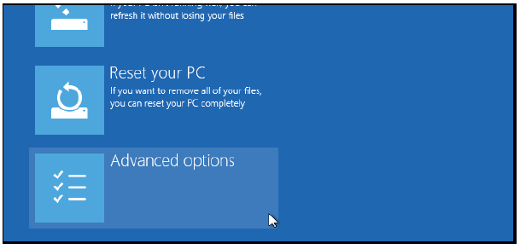
Then Startup Settings. | 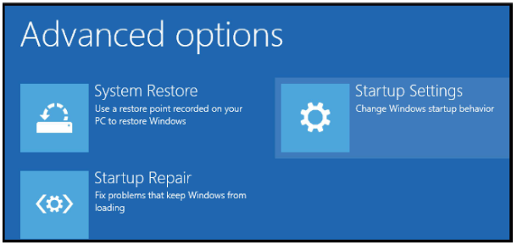
Since we are modifying boot time configuration settings, you will need to restart your Computer one last time. | 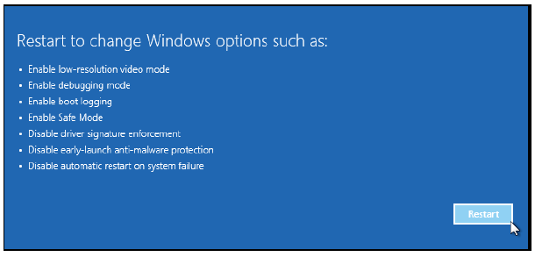

Finally, you will be given a list of startup settings that you can change. The one we are looking for is “Disable driver signature enforcement”. To choose the setting, you will need to press the F7 key. | 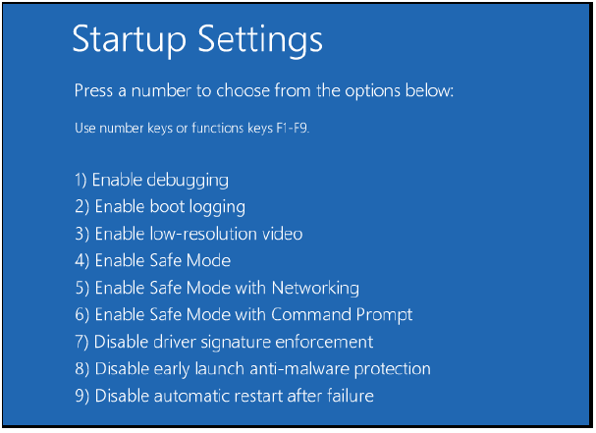
Now you are ready to install the drivers for KEM-Net.  Connect the J-KEM controller to the PC using a USB cable.  Right click on the Start Menu (the windows icon in the lower left corner of the screen), then from the popup menu select Device Manager.  The device manager will display an Icon titled JKEM USB interface and it will have a yellow exclamation mark in it. | 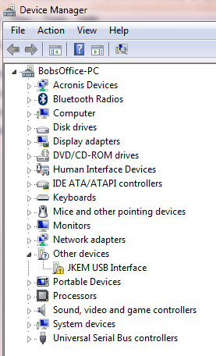
NOTE – You will return to this step (just keep reading)  Double click on the icon to load its properties, then click on the Update Driver button. | 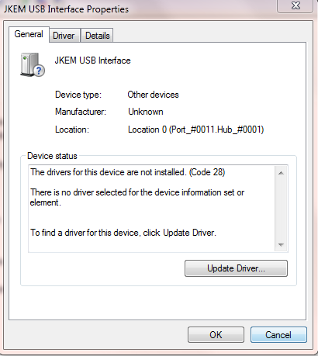

Select Browse my computer for driver software. | 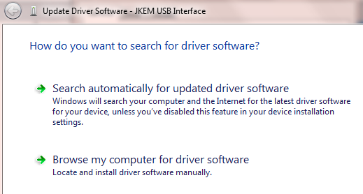
Click the browse button, then navigate to the folder titled J-KEM Controller Drivers. Select the folder, then click on the OK button.  Now click the Next button. | 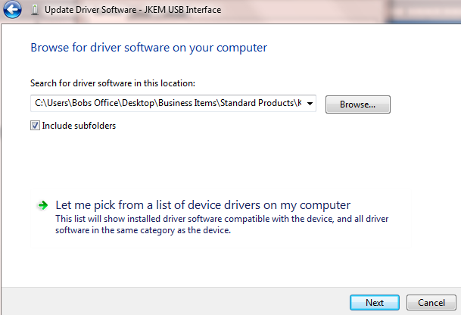  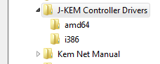
Windows will display this warning. Click on Install this driver software anyway. | 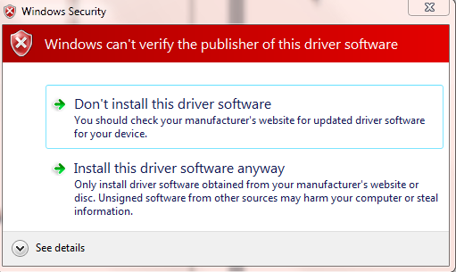

After installing the driver, this window appears indicating that the driver was installed successfully.  Click the close button | 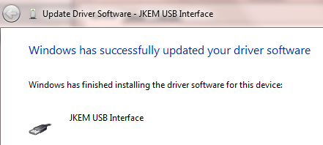Clci
Now Windows returns to the Device Manager screen.  KEM-Net has two sets of drivers that must be loaded manually. One is for the USB interface (which you just loaded) and one is for a Virtual Comm Port interface. If you now look at the device manager window, you’ll note that the yellow “USB Serial Interface” icon has disappeared, but is replaced with the yellow icon “USB Serial Port”, this is the second driver they must be manually loaded.  Double click on this icon and manually load this driver as you did the previous driver. If you need step-by-step instructions, return to the step (5 steps ago) titled “You will return to this step” | 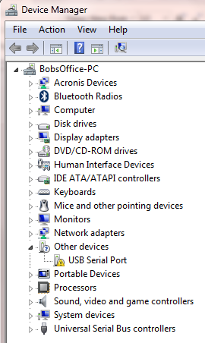
After completing these steps, the drivers for KEM-Net will be loaded. Unplug the USB cable from the controller and quit the KEM-Net software. Plug the USB cable back in, the start KEM-Net and you should see an image of your controller on the PC screen.

